**DATABASE DOCUMENTATION – POLICE STATION MANAGEMENT SYSTEM**

This document provides a comprehensive overview of a database system designed to manage information related To Police Station. The database is structured to store and maintain data with referential integrity across multiple entities. The goal is to create a robust system that can manage a large volume of data while ensuring efficiency, accuracy, and scalability.

The database comprises four main tables:

**Police Station**: This Table contains data related to police station.

**Inspector Details**: In this table information is related to the head of that particular station.

**No. of. Case’s**: This table is related to the case registered in that police station.

**Zone Details**: In which zone the police station is located that details is stored in this table.

* Database Schema Overview:

The database consists of the following four tables, with details on their columns, data types, and relationships:

Police Station

Inspector Details

No. of. Case’s

Zone Details

* Table Descriptions
* Table no.1 – Police Station =Information about the police station table, columns and their data types.

Table Structure:

|  |  |  |
| --- | --- | --- |
| **C Column Name** | **Data Type** | **Descript Description** |
| Police_ Station_ id | IN T Varchar (120) | Id no of police station |
| Station name | VARCHA Varchar (120) | Name of police station |
| Police staff | VARC INT | No of police staff members for  That police station |
| St Inspector_ id | VARCHA Varchar (120) | Foreign_ key to inspector details |
| Station_ pincode | IN INT | Foreign_ key to Zone details |
| No_ of_ cases | IN INT | For Foreign_ key to no of cases |

**Primary key =**

* Police_ station_ id

**Foreign key =**

* Inspector_ id = inspector details (Inspector_ id)
* Station_ pincode = Zone_ details (Station_ pincode)
* No_ of_ cases = No_ of_ cases (No_ of_ cases)
* Table no. 2 – Inspector Info = Detailed info about the inspector with their datatypes.

Table Structure:

|  |  |  |
| --- | --- | --- |
| **Colum Column Name** | **Data Type** | **Description** |
| Inspector_ id | I Varchar (120) | Inspector identity no |
| Inspector name | Varchar (120) | Name of the inspector |
| Age | INT | Age of Inspector |
| Joining date | Date | Joining Date of Inspector |
| Salary | INT | S Salary of Inspector |

Primary Key – Inspector_ id

* Table no. 3 – no_ of_ cases = All the information related to the cases registered in stations stored in these table.

Table Structure:

|  |  |  |
| --- | --- | --- |
| **Colum Column Name** | **Data Type** | **Description** |
| Max_ case_ type | I Varchar (120) | Maximum case Type registered |
| Min_ case_ type | Varchar (120) | Minimum case Type registered |
| No_ of_ cases | INT | No of cases registered in that station |
| Avg _ solving_ days | INT | Average days required for solving  the case |

Primary key – No_ of_ cases

* Table no. 4 – Zone_ Details =The location related data stored in this table in particular column with their datatypes.

Table Structure:

|  |  |  |
| --- | --- | --- |
| **Colum Column Name** | **Data Type** | **Description** |
| St Sation_ pincode | INT | Pincode of station that in which the  Station is located |
| Station_ Zone | I Varchar (120) | In which Zone station is located |
| City | Varchar (120) | In which City station is located |
| State | Varchar (120) | In which State station is located |

Primary key – Station_ pincode

* ETL DAIGRAM:

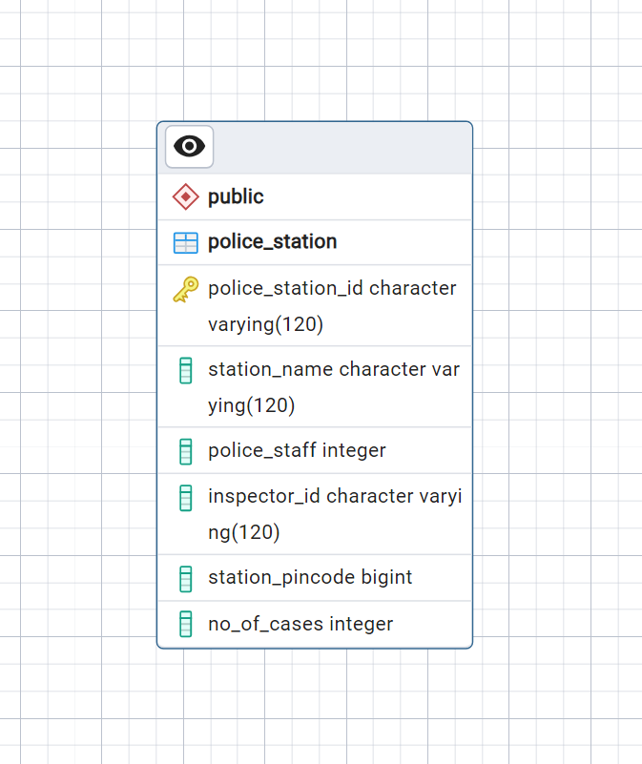 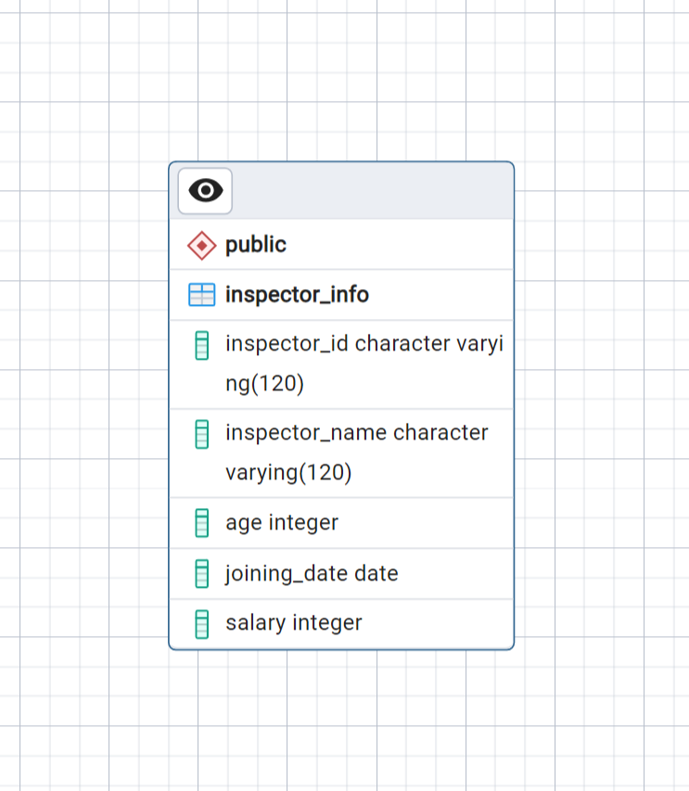

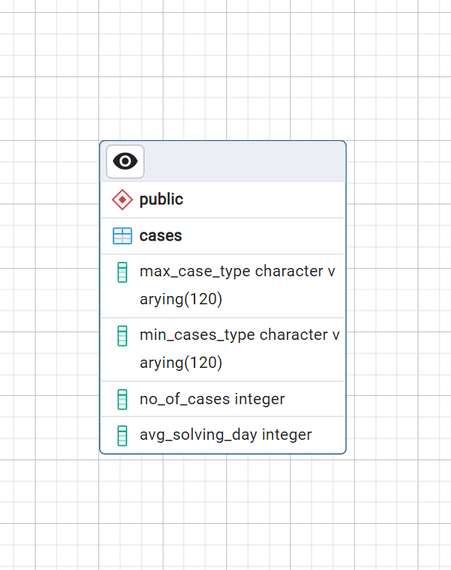 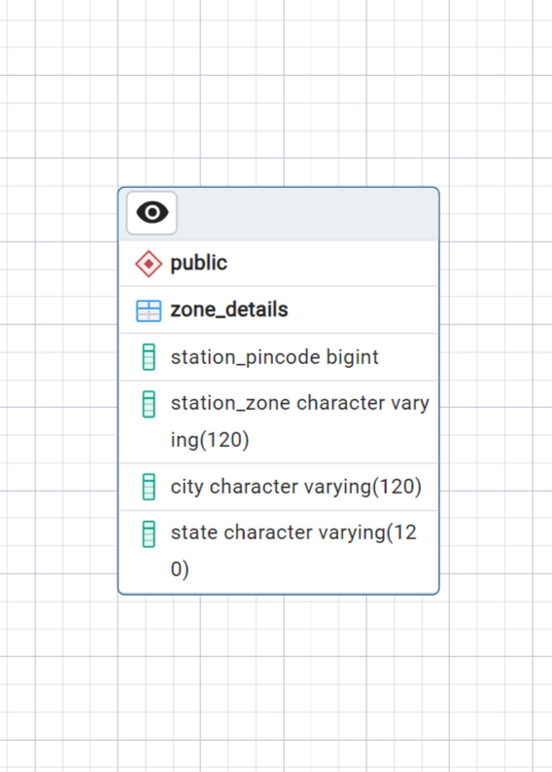

* Conclusion:

This documentation presents an in-depth look at the database design, including its schema, table descriptions, relationships, and constraints. The database is optimized for maintaining all the information related to police station records with data integrity and normalization at its core. This structure allows for efficient data retrieval, scalability, and support for further extensions if needed.